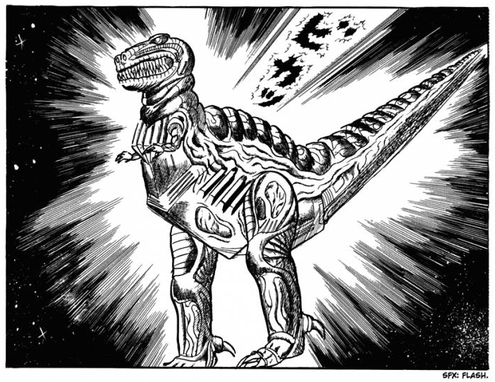

There should be no surprise that the ship from the exterior appears to look like a Tyrannosaurus Rex. Given that it was constructed, according to President Young, by the elusive genius known as Dr. Chicken George, the reasoning behind the ship’s design and the extent of its features are unknown. Entrance into the ship is via its mouth, resting its head on the ground in a sentient motion to provide easier access for passengers.

President Young informed you prior to boarding the ship of its initial purpose. The great Dr. Chicken George was obsessed with the notion of saving animals by sending them out into space. He had initially created this spaceship to house all the animals of the world as a futuristic Noah’s Ark. It is unsure whether Dr. Chicken George accomplished this goal already or if the animals were able to board the ship. The world’s wildlife mysteriously disappeared along with the death of nature, a pairing which could not simply be coincidence.

The area you and your shipmates can currently interact in is a paradise. Believe it or not, the inside of the ship looks and feels exactly like how the Earth was more than a few centuries ago. A beautiful, sizeable log cabin resides in the middle of a large grassy plain adjacent to a forest and mountains. There is plenty of undiscovered area aboard this ship, although it appears that many of the other locations are locked off from you.

In the brief time you’ve been aboard, you’ve also seen some strange alien-like plant creatures scurrying around. Even though the animals of Earth most recently are clones of extinct animals or bizarre and horrifying fusions of them, you are certain that you have not seen these creatures before. You can’t tell whether they are friend or foe.